Low cost thermic system for transfusable substance improving
Braun Barbu-Cristian¹[0000-0003-3837-0341], Drugă Corneliu-Nicolae¹[0000-0002-7253-4357], Șerban Ionel¹[0000-0002-3856-3437], Mitu Leonard¹[0000-0002-4748-1951]
¹ Transilvania University of Brasov, Romania
braun@unitbv.ro
Abstract. The paper presents a stage of research regarding the design, development and testing of a flexible, low-cost system that allows improving the process of transfusion of vital substances. It is primarily about the process of heating and bringing them to an optimal temperature from the point of view of thermal biocompatibility for the beneficiary. From the implementation point of view, the heating solution proved to be an effective one both in terms of process duration and in reducing energy consumption. Regarding the functional testing, the method of recording and measuring the temperature values ​​of transfusable substances using an infrared thermal imaging camera was used. Based on the results related to temperature measurement, finding values ​​very close to the ideal ones specific to such processes, it was possible to conclude that the method is efficient, reliable, low-cost, and it can be implemented in the near future in hospitals and of blood transfusion centers, for all categories of subjects, regardless of the conditions that require a transplant.
Keywords: Transfusable Substances, Thermal Imaging Camera, Temperature, Blood, Biocompatibility
- Vital substances transfusion – solution and trouble
Nowadays, the importance of transfusion is absolutely undeniable, in the context where daily thousands and thousands of people need vital substances to survive serious illnesses or accidents. It is well known internationally that a major problem, especially with regard to blood transfusion, is the insufficient number of donors [1], [2].
But another problem, perhaps equally important, which, until recently, was not given too much importance is that concerning the conditions under which a transfusion must take place. A particularly important aspect, apart from respecting the blood group, regarding the transfer is represented by sanitary hygiene conditions. But these aspects are far from completely solving the problem of transfusion of vital substances in general (blood, lymph, etc.). In addition to the issue of biocompatibility, a particularly important aspect concerns the environmental conditions regarding the transfusion (temperature, flow rate, pressure of the transfused substances). If until now the problems related to hygiene, blood group, transfusion conditions from the point of view of flow and pressure have been largely solved, the problem of ensuring an ideal temperature for transfusion is the subject of much more recent research. For this reason, the problem of heating transfusable substances (especially blood) to a temperature as close as possible to that of the beneficiary person is currently increasingly addressed. Thus, recent research has led to the solution of this aspect as well, but the major problem that remains unsolved for the time being is related to the costs and the duration of the heating process, which, too often, is far too long in relation to the time it must have place the transfusion [3], [4].
- Proposed solution for transfusion condition and safety improvement

2.1 Critical review of existing state-of-the-art solutions for heating transfusable substances

In order to find the better solution in terms of costs and efficiency, a state of art meaning the actual solutions was performed in the first stage of the research. For this purpose different heating transfusable systems were analyzed [5]. The first one refers to the FLUIDO COMPACT device system for warming blood and fluids from low to moderate flow rates, using an infrared technology as a heating method [6], [7]. Another systems is HOTLINE that provides blood and warm fluids needed by patients, with the heating technique based on a unique coaxial water recirculation method, namely through a triple lumen tube [8], [9]. M WARMER is another type of blood and fluid warmer, specialized for emergency transfusions. The system has a portable fluid warmer that warms blood from cold (4°C) to body temperature in seconds and has the capacity to warm up to 1.5 liters of fluid. BH-600A blood warmer, infusion solutions and nutrition, being suitable for any type of infusion support. To minimize temperature loss during general anesthesia, intravenous fluids are warmed to body temperature before infusion [11]. BARKEY PLASMATHERM is an electronic system used primarily for heating and thawing bags or bottles of fluids to be administered to patients by infusion or transfusion [12], [13]. 3M™ RANGER™ SYSTEM is built to keep warm blood, blood products and other infusible fluids which delivers them with a flow rate of up to 500 ml/min. This device uses dry heating technology, which means faster and more accurate temperature control, minimizing the risk of fluid overheating[14], [15].

In the tables 1 and 2, the most relevant technical characteristics of the 7 best-performing transfusable substance heating systems on the market are summarized [5].
Starting from the information summarized in tables 1 and 2 regarding the technical-functional characteristics of existing solutions on the market regarding the solution to the problem of heating transfusable substances, was done a detailed critical analysis. For this purpose, a small software application was programmed, in the LabVIEW environment, for the objective and efficient establishment of the optimal solution. The purpose of this stage of the study is to develop a somewhat similar, low-cost and more accessible solution for transfusion center staff [5], [16].
Table 1. Main technical specifications for the 7 best-performing systems_Part1.
Device | Supply [V] | Maximum power consumed [W] | Transfusible line length [mm] | Maximum heating temperature [°C] | Temperature precision [°C]
FLUIDO COMPACT | 220-230 | 160 | 700 | 39 | 0.1
HOTLINE | 220-230 | 115 | 1000 | 41.5 ± 0.5 | 0.2
S-LINE BARKEY | 220-230 | 75 | 1500 | 39 ± 2 | 0.2
M WARMER | Portable battery (12V) | 15 | 500 | 39 ± 3 | 1
BH-600A | 220-230 | 45 | 800 | 42 ± 0.5 | 0.5
BARKEY PLASMATHERM | 220-230 | 1600 | - | 37 ÷ 45 | 0.1
3M RANGER | 220-230 | 900 | 1200 | 41 | 0.1
Table 2. Main technical specifications for the 7 best-performing systems_Part2.
Device | Solution heating time [min] | The number of bags that can be heated | Heating method | Price [Euro]
FLUIDO COMPACT | 1 - 2 | 1 bag of 450 ml | infrared | 2000
HOTLINE | 4 | 1 bag of 450 ml | coaxial water recirculation | 1500
S-LINE BARKEY | 2 | 1 bag of 250 ÷ 300 ml | dry heating (metallic plate) | 2000
M WARMER | up to 2 | 1 bag of 150 ml | dry heating (metallic plate) | 600
BH-600A | 5 | 1 bag of 250 ÷ 300 ml | dry heating (metallic plate) | 450
BARKEY PLASMATHERM | 7 ÷ 9 | 4 bag of 500 ml or 8 bag of 250 ml | dry heating (2 thermal pillows with recycled water) | 10000
3M RANGER | 2 | 1 bag of 450 ml | dry heating (metallic plate) | 3000

The software application for critical analysis involved the definition of some text boxes (marked in red) as input variables in the window-panel, the one for the user interface, which represent all the criteria for which the critical analysis is done. In blue, all the output variables, of numerical type, have been defined to display the scores associated with each analysis criterion, separately. Separately, a numeric output variable was provided to display the total score for each analyzed solution. For example, the BARKEY PLASMATHERM model was chosen and its specific characteristics were entered in the text boxes marked in red, and in the blue boxes the customized score was automatically generated, finally displaying the critical analysis grade. The example is illustrated in figure 1 [5], [12], [16].
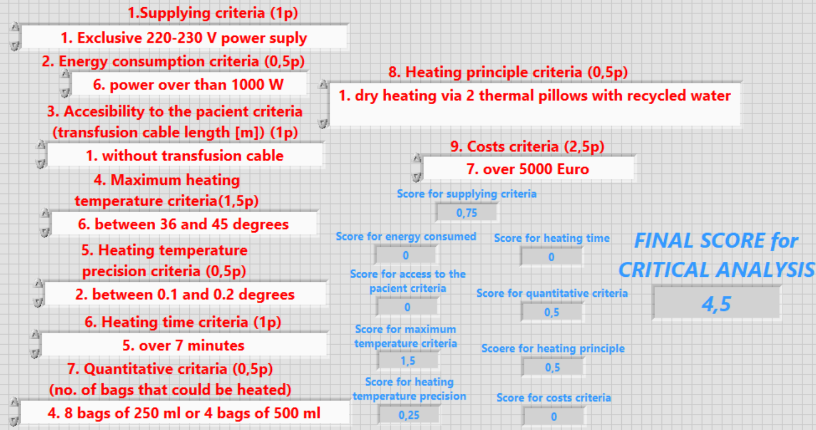
Fig. 1. Assisted critical analysis example for BARKEY PLASMATHERM heating system.
Based on the information entered in the table that reviews the technical-functional characteristics for each heating system, each entry-type entity, as an analysis criterion was set to include all possible feature variations. For this purpose, for each type input variable dialog box has created a predefined list of options that facilitate easier access to the necessary information. Each of these analysis criteria, as a selective input variable, was related to a multi-case programming structure (Switch), including, for each option, a separate case within that structure.
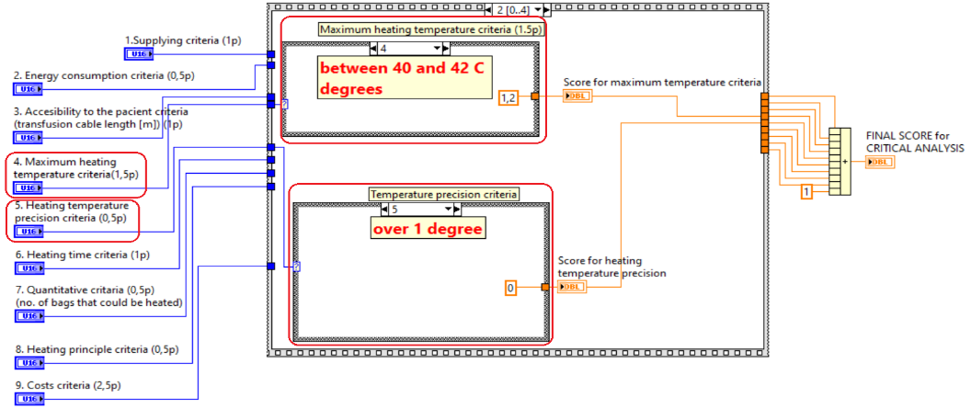
Fig. 2. Exemplifying the programming of multiple cases of partial scoring for the variables associated with analysis criteria no. 4 and 5.
An example of the relationship of the criteria presented above in the graphical programming window can be seen in the figure 2. Similarly, partial scoring algorithms were programmed for all criteria analysis.
Once completed the application it, was used, through successive runs, for the critical analysis through all the criteria, for each individual solution, as shown in the heating systems description table. The final scores associated with each heating system were thus centralized in table 2 [5].
Table 3. Awarding the final score obtained following the critical analysis for each variant of the heating system, by using the developed software application
No. | Heating system | Final obtained score
1 | FLUIDO COMPACT | 6.45 from 10.00
2 | HOTLINE | 7.50 from 10.00
3 | S-LINE BARKEY | 6.75 from 10.00
4 | M WARMER | 7.05 from 10.00
5 | BH-600A | 7.90 from 10.00
6 | BARKEY PLASMATHERM | 4.50 from 10.00
7 | 3M RANGER | 6.55 from 10.00
As a result, none of the devices reviewed scored higher than 7.90 points out of 10, which means we can't pick a "winning" device as none met all the criteria reviewed.
Thus, only the best features of each device can be chosen, the optimal solution being that of designing, developing and testing a device taking into account the most suitable criteria or improving one of the mentioned devices. For this purpose, it is known, with the help of critical analysis, what exactly should be adjusted (for example, too high cost of the device, better temperature accuracy, etc.).
In order to start the conception of the installation and subsequently its design and realization, the choice of the most suitable method of ensuring the optimal temperature of the substance on the route to the beneficiary must first be taken into account.
The company Smiths Medical, through a comparative study presents the differences between their HOTLINE device and the other heaters by conventional fluids. Unlike the HOTLINE® Blood and Fluid Warmer, conventional fluid warming systems suffer from an unwanted cooling process between the heater and the patient connection, especially at lower routine flow rates. In these systems, active heating ceases after the blood or fluid has passed through the conventional heater, allowing the fluid to cool in the intravenous line before being delivered to the patient [5], [8], [9].
In the study conducted by the University of Florida, the Department of Anesthesia, the heating-based Ranger device was compared dry and the previously mentioned HOTLINE device, evaluating the flows and heating efficiency. This study is based on several tests and experiments on these devices. One of these consisted of using saline at room temperature (21°C) and packed red blood cells at 10°C using a pressure of 90 mmHg (gravity equivalent) and 300 mmHg. The outlet flow from each device was connected to an in-line thermistor and simultaneous measurements of outlet temperature and flow volume per minute were recorded. Additional data points were obtained with a peristaltic pump that provided flow rates of 1–6 l/h through each device. Calculations were made on the effect of these flow rates and outlet temperatures on the average body temperature of a 70 kg patient [5], [8], [9].
To demonstrate the clinical effect of the observed differences in flow rate and temperature output with each blood/fluid warmer, the mean body temperature drop for a 70 kg patient receiving RBCs at 10°C or saline at 21°C was calculated with Hotline, Ranger, or no warmer at 1–6 L/h and at maximum flow rates, as would occur in a major fluid transfusion, with the following formula:
ΔMBT = ((T_{F} – T_{pt}) S_{F} * V_{b}) / (S_{pt} * W_{t}) (1)
where: ΔMBT indicates the change in average body temperature, T_{F} indicates the temperature of the infused fluid, T_{pt} indicates the patient's core temperature (37°C), S_{F} indicates the specific heat of the infused fluid for blood, V_{b} indicates the volume of infused fluid (in liters), S_{pt} indicates the specific heat of human tissue and W_{t} indicates the patient's weight (in kilograms) [5].
From the studies reviewed previously, we were presented with the disadvantages and advantages of the most popular methods of warming blood and fluids for transfusion, but no method was satisfactory. Devices based on dry heating through a metal plate are among the most widely used, but fluids have been found to suffers from cooling between the heater and the patient connection, especially at lower routine flow rates, because active heating ceases after the blood or fluid has passed through the heater, which will cause the fluid to cool through the intravenous line before it is delivered to the patient [5].
Thus, another type of device was studied based on the coaxial water recirculation method (through a triple lumen tube), which solves the problem of cooling the liquid on the way to the patient, but another problem appears with this device, namely that in rapid transfusions with higher flow rates, the outlet temperature of the fluid decreases, because the recirculation solution would not have enough time to warm up at increased and faster flow rates.
The German company BARKEY has developed a new device for warming blood and thawing plasma using a dry heating method using two thermal pads with recirculated water that seems to be the solution to the problems of the other existing devices. For optimal use, up to four bags of blood or plasma have been experimented with, placed between two water-filled cushions, where the water is pumped into the cushions continuously [12], [13].
In table 4 the main advantages and disadvantages of these methods of ensuring the optimal temperature to the patient are briefly presented for a better interpretation of the final choice [5].

Table 4. Main advantages and disadvantages for the different heating solutions
Heating method | Advantages | Disadvantages
dry heating using a metallic plate | - only 2 minutes for heating;  - low cost, easy using | - direct contact with the sanguine bags;  - fluid cooling along the way to the patient
co-axial water recycling (by a triple lumen tube) | - maintains the constant temperature on the way to the patient;  - there is no direct contact with the sanguine bags | - high risk of contamination of the transfused substance;  - low exit temperature for high debits
dry heating using two thermal pillows with recycled water | - there is no contamination risk of the transfused substance;  - no direct contact with the fluid bags;  - mixing anti-coagulation fluids | - high costs;  - longer heating time
2.2 Design and development of the low-cost system for heating transfusable substances
In conclusion, following all these comparative studies, the solution was chosen to design a device based on the dry heating method using two thermal pillows with recirculated water, with the aim of making the product at a lower cost compared to the current purchase price of a device that uses the same heating method [5].
For system designing, in a first stage, the problem of heat transfer calculation, the volume of fluid subject to heating and the sizing calculation of the tubing was raised. For the heat transfer, first of all the thermal conduction was taken into account. Thermal conduction is based on Fourier's law, whereby the direction of heat transfer is from higher temperatures to lower temperatures, and which can be expressed by the following equation:
q_{x} = -K (dT/dx) (2)
where: The heat flux 𝑞_{𝑥} [W/m²] is the rate of heat transfer in the X direction per unit area perpendicular to the direction of transfer and which is proportional to the temperature gradient, dT/dx, in this direction; The parameter K is the thermal conductivity [W/m⋅K]. The minus sign is a consequence of the fact that heat transfer occurs in the direction of decreasing temperature [5].
From the point of view of calculating the volume of the recirculated water type heating agent, the following hypothesis was taken into account: for the use of the two thermal pillows, a volume of water sufficient to fill the 2 containers must be used, but not too much because it will require a higher water heating power from the electrical resistance part. According to the capacities of the 2 manufactured thermal pillows, namely 2000 ml each, a tank with a volumetric capacity of 5000 ml was chosen, because filling the bags will require a volume of 4000 ml and plus 1000 ml that will have to remain in the tank, a volume of 5000 ml that would be suitable for the heating fluid volume.
For the sizing of the piping, it was taken into account that the transmission of water from the tank to the thermal pads will require a predetermined route by means of connecting hoses. These hoses will have the diameters required by the inlet channels and output of the thermal cushions, respectively of the pump which are 6 mm. Therefore, hoses with Ø 5x7mm (5 mm inside by 7 mm outside) will be used, which will be forced to be clamped. The diagram of the heating route of the recirculation solution is represented in figure 3 in which the order of transmission of the heated water from the tank and back to it is highlighted in a continuous recirculation process [5].
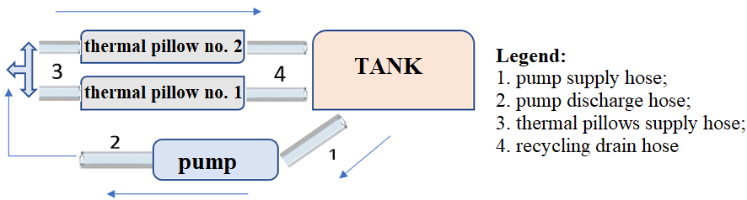
Fig. 3. Scheme of the recirculation solution heating path
To calculate the flow rate, the fluid pressure was taken into account, through the Hagen–Poiseuille equation that describes the pressure drop due to the viscosity of the fluid. To calculate flow from pressure, the formula is expressed as:
Q = [π R⁴ (p₁ – p₂)] / 8 μ L (3)
where: (p1 – p2 ) = Δp is the pressure difference between the ends of the pipe (pressure drop), μ is the dynamic viscosity of the fluid, L and R are the length and radius of the pipe segment [5], [17].
Regarding the constructive principle, the device was designed and made of the following components: the water tank, the outer casing, the electronic command and control block, the thermal pillow storage tray.
The electronic control scheme was initially designed in the form of a block diagram highlighting the most important routes of the component elements. The block diagram includes the most important blocks and systems of the installation, namely: the command and control block, the detection block that transmits the information taken from the 2 temperature sensors to the microcontroller, the actuation system presents the servomotor that operates based on the information received from microcontroller, the user interface includes the LCD screen, buttons and buzzer where the information is visualized, and finally the power system based on a 12V power supply that will power the command and control block and the tank that supplies water to the pump (figure 4). [5].
After the design of the system, the necessary components were prototyped and procured, then their assembly followed, in figure 5 the final version is shown, following the practical implementation [5].

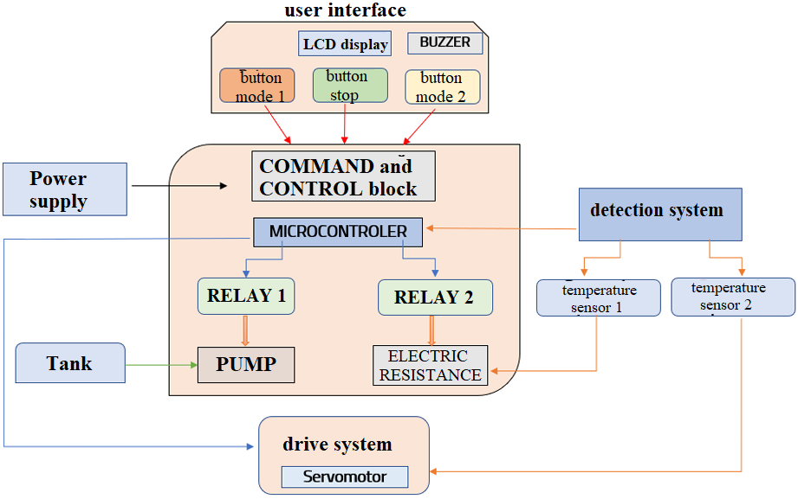
Fig. 4. Block scheme of the designed system.
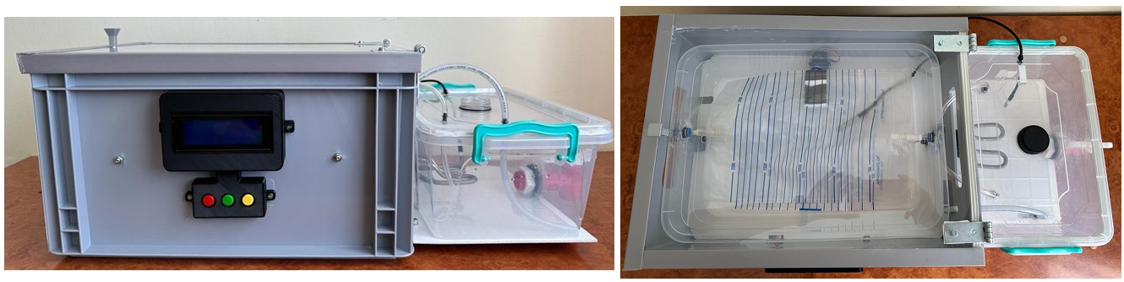
Fig. 5. Final practical realization of the system.

Once the system was realized and tested from a functional point of view, a software application was programmed, by interfacing the hardware development board used to name the Arduino UNO. In the first stage of creating the program code, predefined libraries were introduced for certain components in the project, such as the LCD screen, the I2C module, the DALLAS 18B20 temperature sensor and the servo motor. The next step was to define the pins for making the connections with the previously mentioned components, along with buttons, relays, water pump and buzzer. At this stage the addresses for the two temperature sensors were declared and for the LCD screen as well as the upper and lower limits for the temperature sensors [5]. A flowchart for programing algorithm is shown in figure 6.

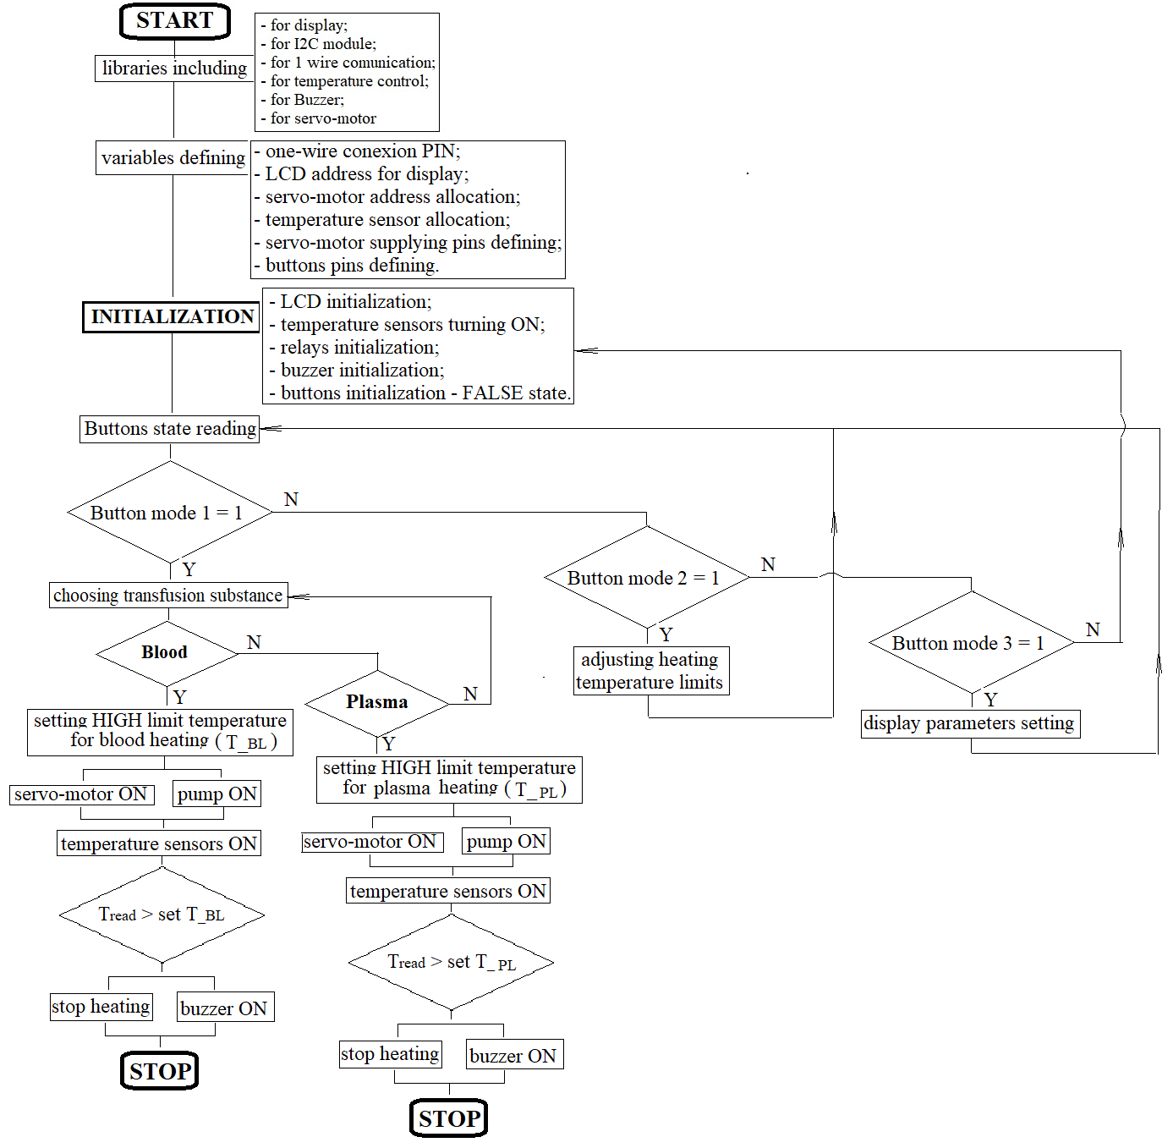
Fig. 6. The first stages of the source code to include libraries and pins defining.
- Results and discussion on the proposed heating transfusion system
In this research, to ensure the sufficiency and accuracy of the developed heating system, a comparative study between the values given by temperature sensors and real temperature before and after heating has been done. For this purpose, a FLIR Systems thermal imaging camera was used for more accurate system testing. It generates a thermographic image of a scanned object based on the radiation it emits. The thermographic chamber is shown in figure 7, next to the containers subjected to the test [5], [18].
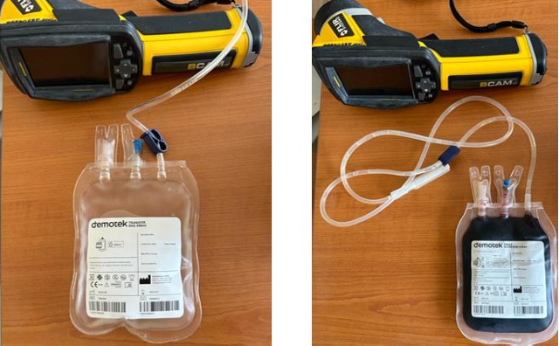
Fig. 7. The thermal imaging camera and the containers to be tested.
The initial temperatures of the containers were 9.4℃ for distilled water and 15.8℃ for blood. Distilled water was used to simulate plasma, and therefore it was desired to have a lower temperature than blood, since plasma is stored at lower temperatures than blood. These containers were inserted into the machine and approximately 10-15 minutes were waited until the operating programs were completed. Meanwhile, the temperature of the water tank was also measured and it was found that initially the water in the tank had a temperature of 22.6℃, and at the end of the heating process it reached 48℃, because in the plasma heating mode a higher water temperature is desired to shorten the waiting time, the plasma being frozen in storage.
Until the final measurement of the temperatures of the containers, the measurement of the thermal pads was also carried out, to see what temperature they have as well. Thus, with the thermal imaging camera, the temperature of the thermal pads was measured and it reached a temperature of 40℃ in the case of the blood heating module and 44℃ in the case of the plasma heating process.
The final point was to measure the temperatures of the 2 containers at the end of the heating process, and during the process, the temperature reached 26.7℃. After an interval of about 5 minutes it reached the final temperature of 35.6℃. [5], [18]
It can be seen that the temperature gradation scale in the second image of figure 8 reaches up to 35.6℃ in the red areas of the bag, which means that an average temperature of the whole bag (there being only measured locally) would be 35 ℃, temperature close to 37℃, desired value reached. Due to the heating functioning and also thermographic measuring it was proved than the differences between measured heating temperature and thermographic measured temperatures did not exceed 1.5 ÷ 2 degrees. In conclusion, following the tests carried out, the device fell within the required requirements, achieving good functionality, meaning only small improvements [5].

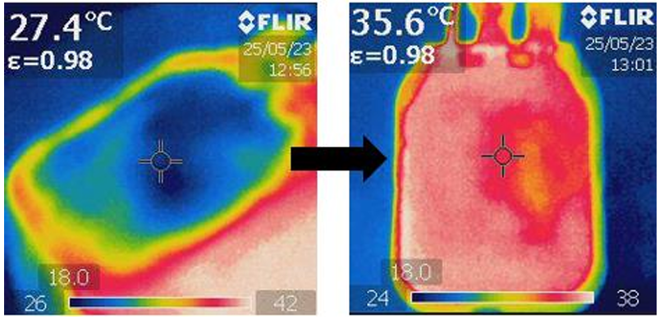
Fig. 8. The temperatures of the containers measured with the thermal imaging camera: the initial and the final temperature (after heating).
- Conclusion on the developed heating transfusion system
From the point of view of the operation of the designed system, it will have to follow certain steps towards proper use and will work according to certain predetermined parameters and characteristics.
To certify the efficient and safe operation of the designed and built system, it was tested for all its operating modes. First of all, the testing was done from the point of view of the transfusion regimes, for both substances, both blood and plasma. For this purpose, all the necessary work stages were completed, respecting the imposed technological conditions.
It was found that the heating system is functional and reliable, and can be implemented on a large scale, in clinics and hospitals, especially in case of emergency interventions [5].
Acknowledgment: The research described in the paper was largely due to the contribution of Medical Engineering graduate students, 2023-2024 promotion, within the Diploma Project, the practical activity being carried out in the laboratories of Transilvania University.
Coflict of interest. The authors declare they have no conflict of interest.

References
- S. Geneva: The Clinical Use of Blood Handbook (2002), link: https://apps.who.int/iris/bitstream/handle/.
- W. H. Organization: Educational modules on clinical use of blood (2021), link: http://www.transfusion.ru/2022/03-04-1.pdf.
- P. E. Marik: Transfusion of Blood and Blood Products, PubMed Central (2014), link: https://www.ncbi.nlm.nih.gov/pmc/articles/PMC7124112/.
- D. M. Harmening, „Modern Blood Banking & Transfusion Practices 6TH EDITION (2012), link: https://www.pdfdrive.com/modern-blood-banking-transfusion-practices-sixth-edition e60355202.html.
- Mareș, I.: Proiectarea unei instalații pentru pregătirea pentru administrare către pacient a sângelui, produselor din sânge și a soluțiilor perfuzabile, Diploma Project, coordinator: Prof. dr. ing. Luciana CRISTEA, Șef lucr. dr. ing. Barbu BRAUN (2023).
- T. T. S. Company: Fluido® Compact (2022): link: https://www.tsc-group.com/patient-temperature management/products/fluido-compact/.
- T. 37 Company: Fluido® Compact Fluid and Blood warming, Manual de utilizare (2022), link Available: https://www.tsc-group.com/app/uploads/sites/3/2022/05/INT-R683-EN-3-10-17-Fluido Compact-User-Manual-English.pdf.
- U. Medical: HOTLINE Blood and Fluid Warmer - LEVEL1 Brochure.pdf (2021), link: https://www.uslmedical.co.nz/temperature-management/blood-and-fluid-warmers/hotline blood-and-fluid-warmer-level-1.html#!tab-files.
- I. Medical: HOTLINE® Blood and Fluid Warmer (2022), link: https://www.smiths medical.com/products/temperature-management/blood-and-fluid-warming-systems/routine flow-fluid-warming/hotline-blood-and-fluid-warmer.
- MEQU: Warm blood saves lives (2021), link: https://mequ.dk/.
- Medfarm: Încalzitor sange si solutii perfuzabile BH-600A (2022), link: https://medfarm.ro/aparatura-medicala/produs/detalii-produs-incalzitor-sange-si-solutii perfuzabile-bh-600a-2105.html.
- MedWrench: Barkey Plasmatherm User Manual.pdf, link: https://www.medwrench.com/documents/view/13013/barkey-plasmatherm-user-manual-pdf.
- Barkey: Barkey plasmatherm | plasmatherm V., link: https://barkey us.com/us/product/barkey-plasmatherm--plasmatherm-v/24.
- Hugger™: 3M™ Ranger™ Blood and Fluid Warming System (2022), link: https://www.bairhugger.com/3M/en_CA/bair-hugger-ca/experience-manager-content/3m ranger-blood-and-fluid-warming-system/.
- A. Repanovici, L. Cristea: Bloc operator, Notițe de curs, Universitatea Transilvania din Braşov, 2023.
- Cottet, F.; Ciobanu, O.: Bazele programării în LabVIEW, Editura MATRIX ROM Bucureşti, ISBN 973-9390-56-0 (2008).
- Ministerul Sănătății Publice: Ghidul National de utilizare terapeutica rationala a sangelui si componentelor sanguine umane (2007). link:
https://www.hosptm.ro/files/ghiduri/Ghidul%20National%20de%20utilizare%20terapeutica%20rati onala%20a%20sangelui%20si%20a%20componentelor%20sanguine%20umane.pdf.
- FLIR Systems: User manual FLIR Ex series (2019), link: https://docs.rs-online.com/bd2d/A700000006725722.pdf.

